Enforce least-privilege access through identity-aware, application specific access
policies using Zscaler Private Access (ZPA).

INTRODUCTION:
In modern organizations, applications and data are no longer confined to a single corporate network. With the rapid growth of cloud computing, remote work, and mobile devices, users often access enterprise applications from different locations and networks. This shift has created significant security challenges for traditional network security models such as Virtual Private Networks (VPNs), which typically provide broad network access once a user is authenticated. As a result, organizations require more secure and flexible solutions to ensure that users can access only the resources they are authorized to use.
One of the most effective approaches to address these challenges is the least-privilege access principle. The least-privilege model ensures that users, applications, and devices are granted only the minimum level of access necessary to perform their tasks. By limiting permissions, organizations can reduce the risk of data breaches, insider threats, and unauthorized access to sensitive systems. Implementing this principle requires advanced security solutions capable of verifying user identity, device posture, and application context before granting access.
Zscaler Private Access (ZPA) is a cloud-based Zero Trust Network Access (ZTNA) solution designed to enforce least-privilege access to internal applications. Instead of connecting users directly to the corporate network, ZPA connects authorized users to specific applications through secure, identity-aware, and application-specific access policies. This approach ensures that users never gain full network access and can interact only with the applications they are permitted to use.
The concept of Zero Trust security plays a key role in this approach. Zero Trust assumes that no user, device, or network should be automatically trusted, even if they are inside the corporate environment. Every access request is verified based on multiple parameters such as user identity, device security posture, location, and application policies. By adopting Zero Trust principles, ZPA significantly improves security while maintaining seamless access for legitimate users.
This project focuses on enforcing least-privilege access through identity-aware, application-specific policies using ZPA. The system demonstrates how organizations can replace traditional network-based access methods with a modern Zero Trust architecture. By implementing ZPA, enterprises can securely connect users to applications, protect sensitive data, and reduce the attack surface while maintaining high performance and user experience.
The study also explores the architecture, working mechanism, advantages, and implementation of ZPA in a secure enterprise environment. Through this project, the effectiveness of Zero Trust access control in protecting modern digital infrastructures is analyzed and documented.

ABSTRACT:
With the rapid growth of cloud computing, remote work, and distributed IT environments, securing enterprise applications has become increasingly challenging. Traditional security approaches such as Virtual Private Networks (VPNs) provide users with broad network access once authenticated, which increases the risk of unauthorized access, lateral movement, and data breaches. To overcome these limitations, modern organizations are adopting the Zero Trust security model, which ensures that no user or device is trusted by default and that access is granted only after proper verification.
This project focuses on enforcing least-privilege access through identity-aware and application-specific access policies using Zscaler Private Access (ZPA). ZPA is a cloud-based Zero Trust Network Access (ZTNA) solution that securely connects users to internal applications without exposing the corporate network to the internet. Instead of granting full network access, ZPA allows users to access only the specific applications they are authorized to use based on predefined security policies.
The proposed system evaluates user identity, device posture, and contextual information before granting application access. By implementing application-level segmentation and secure connectivity, ZPA reduces the attack surface and prevents unauthorized lateral movement within the network. This approach enhances data protection, improves access control, and supports secure remote access for employees working from different locations.
The project also studies the architecture, functionality, and implementation of ZPA in an enterprise environment. It highlights the advantages of adopting a Zero Trust architecture in improving network security, simplifying access management, and ensuring better compliance with modern cybersecurity standards. Overall, the system demonstrates how organizations can protect sensitive applications and data while maintaining seamless and secure access for authorized users.

\

Use Case Scenarios
Scenario 1: HR Manager Access to Employee Management System
An HR manager needs to access the internal Employee Management System (EMS) to update employee records and manage recruitment information. The manager is working from home using a company-issued laptop. After launching the ZPA Client Connector, the user authenticates through Azure Active Directory with multi-factor authentication (MFA). ZPA evaluates the user's identity, confirms membership in the group HR_EMS_Users, and checks the device posture, including OS security updates and endpoint protection status. Once validated, ZPA creates a secure micro-tunnel directly to the Employee Management System application. The user can access only the HR system interface without any access to finance or development resources.
Output:
- User successfully authenticated using MFA
- Identity and device posture verified through ZPA policies
- Secure micro-tunnel established to Employee Management System only
- Other internal services such as ERP and internal databases remain inaccessible

Scenario 2: Software Developer Access to Development Server
A software developer working in the IT department needs to access the internal development server to deploy new application code. The developer connects through ZPA using the Client Connector on their secured workstation. After authentication through Azure Active Directory, ZPA verifies that the user belongs to the Dev_Team_Users group. The policy engine checks whether the device is compliant with company security policies such as firewall enabled, updated operating system, and endpoint protection active. Once verified, ZPA grants access by creating a secure connection only to the development server.
Output:
- Developer identity authenticated via corporate identity provider
- Device posture validated according to IT security policies
- Secure application-specific tunnel established to development server
- No access granted to production servers or financial systems

Scenario 3: Customer Support Agent Access to Ticketing System
A customer support agent working remotely needs to access the internal support ticketing platform to respond to customer issues. The agent logs in through the ZPA Client Connector using company credentials and completes multi-factor authentication. ZPA evaluates the user's role in the Support_Agents group and confirms that the device meets security requirements such as active antivirus and approved device configuration. Once verified, the system establishes a secure connection directly to the support ticketing application.
Output:
- Agent authenticated with secure identity verification
- Authorization based on support department group policy
- Application-specific secure connection established
- Internal databases and administrative systems remain hidden

Scenario 4: External Contractor Access to Project Management Tool
An external contractor collaborating with the organization needs temporary access to the internal project management application. The contractor accesses the system using a secure browser-based ZPA access portal. Authentication is performed through a federated identity provider with multi-factor authentication. ZPA policies verify that the contractor belongs to the Project_Contractors group and allow access only during approved working hours. A secure micro-tunnel is created exclusively to the project management tool without exposing the internal network.
Output:
- Contractor authenticated through federated identity system
- Access restricted by time-based and role-based policy
- Secure tunnel created to the project management application only
- No visibility of internal corporate infrastructure

Scenario 5: System Administrator Access to Server Management Console
A system administrator needs to perform routine maintenance on the internal server management console. The administrator connects through the ZPA Client Connector from the corporate office network. After authenticating via Azure Active Directory with multi-factor authentication, ZPA verifies membership in the IT_Admins group. The policy engine ensures that administrative privileges are applied only to the required server management application. ZPA then establishes a secure connection directly to the server console while restricting access to unrelated applications.
Output:
- Administrator identity verified with MFA
- Authorization confirmed through administrative group policy
- Secure application-level access granted to server management console
- Non-related applications remain restricted and invisible

Stage – 1
Title: Enforce least-privilege access through identity-aware, application-specific access policies using Zscaler Private Access (ZPA)

Overview:
Modern organizations rely heavily on cloud applications, remote access, and distributed networks to support their business operations. As employees, partners, and contractors access enterprise resources from various locations and devices, ensuring secure and controlled access to internal applications has become a major challenge. Traditional network security models such as VPN-based access often grant users broad connectivity to the internal network once they are authenticated. This approach increases the risk of unauthorized access, lateral movement within the network, and potential data breaches.
To address these challenges, organizations are increasingly adopting the Zero Trust security model, which operates on the principle of “never trust, always verify.” In this model, every user, device, and access request must be verified before granting access to applications or resources. Instead of allowing full network access, Zero Trust focuses on providing secure and limited access to only the specific applications that users require to perform their tasks.
Zscaler Private Access (ZPA) is a cloud-based Zero Trust Network Access (ZTNA) solution designed to enforce least-privilege access through identity-aware and application-specific policies. ZPA connects authorized users directly to internal applications without exposing the corporate network to the internet. It creates secure, encrypted micro-tunnels between users and applications, ensuring that users can only access the services they are permitted to use.
The system verifies multiple factors before granting access, including user identity, device posture, group membership, and contextual information such as location and connection security. By using these parameters, ZPA ensures that access is granted only to authenticated and authorized users. This approach significantly reduces the attack surface and prevents unauthorized users from discovering or accessing internal applications.
This project provides an overview of implementing least-privilege access using ZPA. It explains how identity-based authentication, role-based access control, and application segmentation can protect enterprise systems from cyber threats. The study also highlights the architecture, functionality, and advantages of Zero Trust access solutions in securing modern digital infrastructures.
Overall, the proposed system demonstrates how organizations can replace traditional network-based access with a secure, scalable, and efficient application-level access model. By implementing ZPA, enterprises can enhance security, protect sensitive data, and ensure safe access to internal applications for employees and external users.
TEAM MEMBERS
Team ID: SWTID-2026-1971

S. No | Name | College | E-Mail ID
1. | PRADAKSHINA S | KPR COLLEGE OF ARTS SCIENCE AND RESEARCH | 23bit041@kprcas.ac.in
2. | KAMALESWAREN J | KPR COLLEGE OF ARTS SCIENCE AND RESEARCH | 23bit018@kprcas.ac.in
3. | NIVETHA S | KPR COLLEGE OF ARTS SCIENCE AND RESEARCH | 23bit038@kprcas.ac.in
4. | YOGESH A | KPR COLLEGE OF ARTS SCIENCE AND RESEARCH | 23bit069@kprcas.ac.in

List of Vulnerability:

S. No. | Vulnerability Name | CWE No.
1. | Broken Access Control | 285
2. | Security Misconfiguration | 489
3. | Software Supply Chain Failures | 447
4. | Cryptographic Failures | 320
5. | Injection | 20
6. | Insecure Design | 73
7. | Authentication Failures | 258
8. | Software or Data Integrity Failures | 345
9. | Security Logging and Alerting Failures | 117
10. | Mishandling of Exceptional Conditions | 209

1.Vulnerability name: Broken access control
CWE: 285
OWASP Category: A01:2025 - Broken Access Control
Description: Authorization is a fundamental security mechanism that determines whether a user, application, or system has the necessary permissions to access specific resources or perform certain actions. In a secure system, once a user is authenticated, the system must verify whether the user is authorized to access the requested data or functionality.
Business Impact: Improper or missing authorization checks in a system can have serious consequences for an organization’s security, operations, and reputation. When a product fails to correctly verify whether a user has permission to access a resource or perform an action, unauthorized individuals may gain access to sensitive information or critical systems. This can lead to significant financial, operational, and legal risks for the business.
Vulnerability path: http://testfire.net/
Vulnerability parameter: http://testfire.net/login.jsp
Steps to Reproduce:
- Access the URL
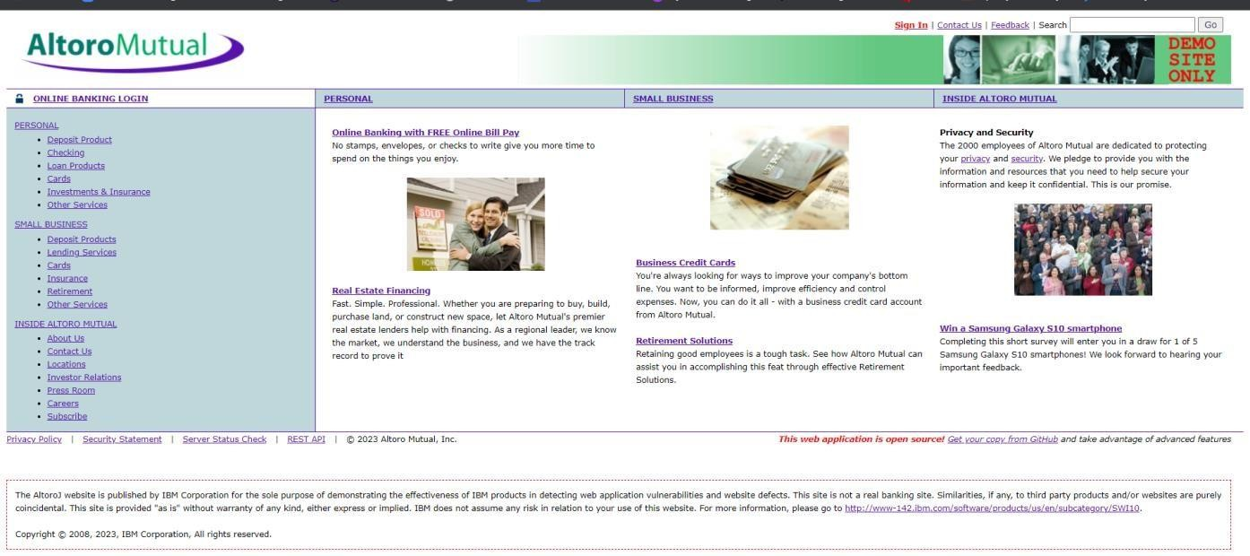

- In the search box we will input some code to perform the vulnerability.
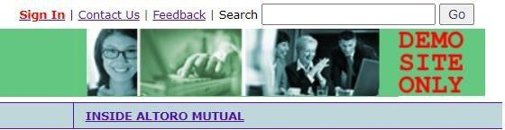

- This displays a harmless pop up alert box with the text saying ‘hacked’

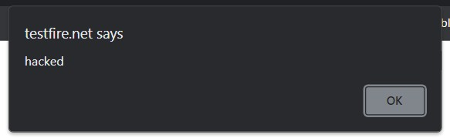

Recommendations
▪ Implement role-based access control (RBAC) to ensure users can access only resources that match their roles.
▪ Enforce server-side authorization checks for every request instead of relying on client-side controls.
▪ Use secure session management and invalidate sessions after logout or inactivity.
▪ Regularly perform security testing and access control audits following guidelines from the OWASP.

2. Vulnerability name: Security Misconfiguration
CWE: 489
OWASP Category: A02:2025 - Security Misconfiguration
Description: Active debug code refers to debugging or testing code that remains enabled in a production system. This code is usually used by developers to identify errors and monitor application behavior during development. If it is not removed before deployment, it may expose internal system details such as file paths, database queries, or configuration information. Attackers can use this information to understand the system and exploit vulnerabilities.
Business Impact: Active debug code can lead to information leakage and increased security risks. Attackers may gain insights into the system architecture and find ways to bypass security controls. This may result in unauthorized access, data breaches, and system compromise. It can also cause financial losses and damage the organization’s reputation.
Vulnerability path: http://testfire.net/
Vulnerability parameter: http://testfire.net/login.jsp
Steps to Reproduce:

- Access the URL


- Now we will try to sign in to this website with admin privileges

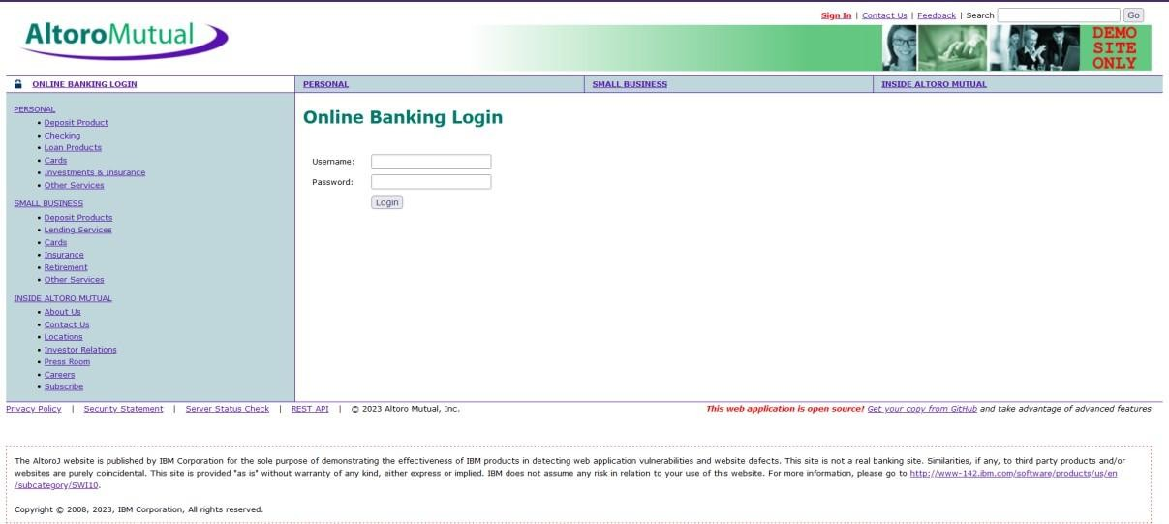
- Also, we will be using burp suite to get requests from the website and know additional information. We use ‘admin’ for the username and password.

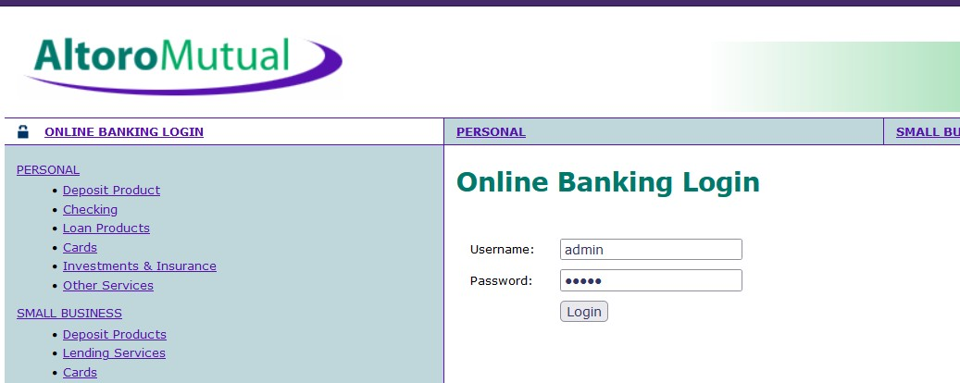
- This request has been received in the burp suite with the username and password as well in clear text.
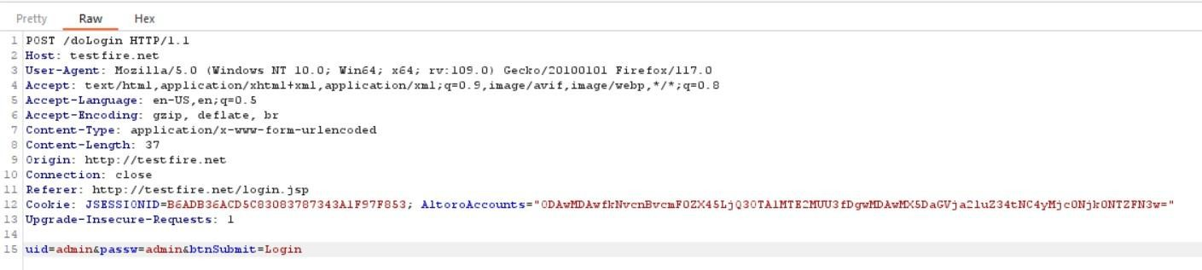
- now we click on forward request in the burp suite and then we will be redirected to the admin user details.

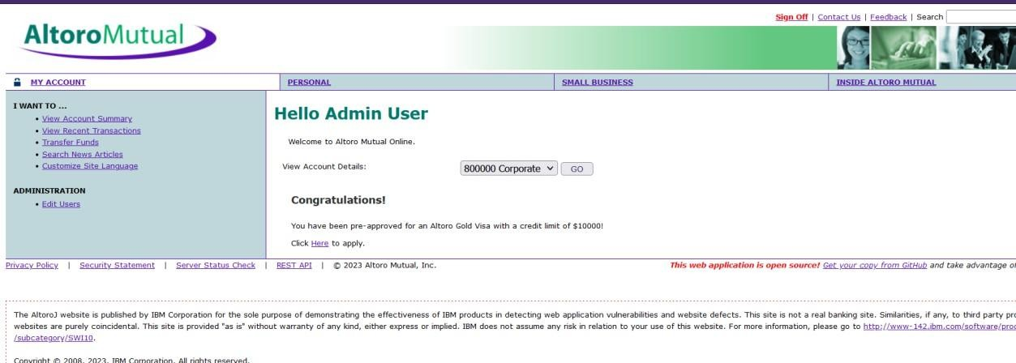

- We can even edit the other users data and delete their login details as well.
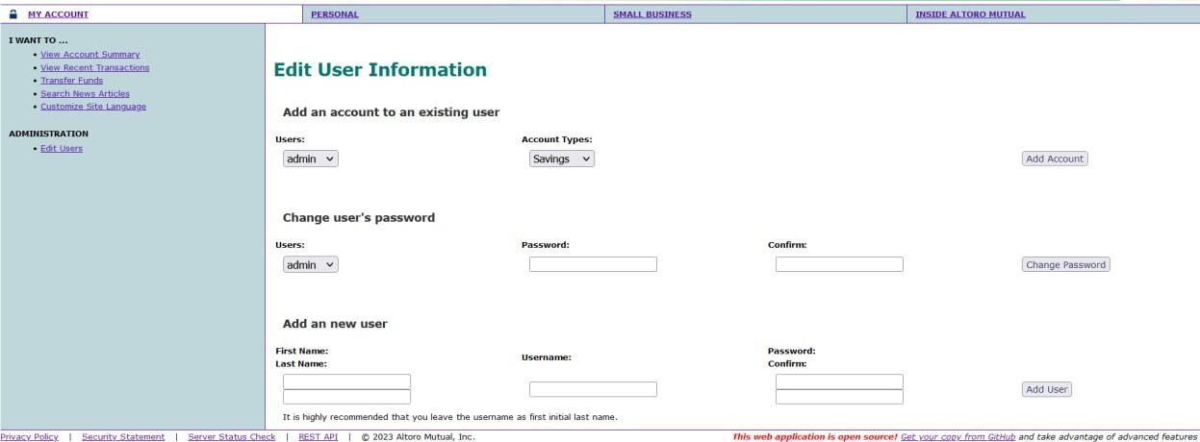

Recommendation
▪ Disable default accounts, unnecessary services, and unused features in servers and applications.
▪ Keep all software components, frameworks, and operating systems updated with the latest security patches.
▪ Implement secure configuration management using hardened configuration templates.
▪ Regularly conduct vulnerability scans and configuration reviews to detect misconfigurations.

3. Vulnerability name: Software Supply Chain Failures
CWE: 447
OWASP Category: A03:2025 - Software Supply Chain Failures
Description: The use of obsolete (deprecated) functions refers to using outdated or unsupported functions in an application. These functions may no longer be maintained or updated by developers and may contain known security vulnerabilities. Continuing to use such functions can reduce system reliability and security. Developers should replace obsolete functions with updated and secure alternatives.
Business Impact: Using obsolete functions can expose the system to security risks and potential attacks. Attackers may exploit known vulnerabilities in outdated functions to gain unauthorized access or disrupt system operations. This can lead to data breaches, system failures, and operational downtime. It may also result in financial losses and damage the organization’s reputation.
Vulnerability path: http://testfire.net/
Vulnerability parameter: http://testfire.net/login.jsp
Steps to Reproduce:

- Access the URL


- Now we will try to sign in to this website with admin privileges but using SQL injection



- Also, we will be using burp suite to get requests from the website and know additional information.

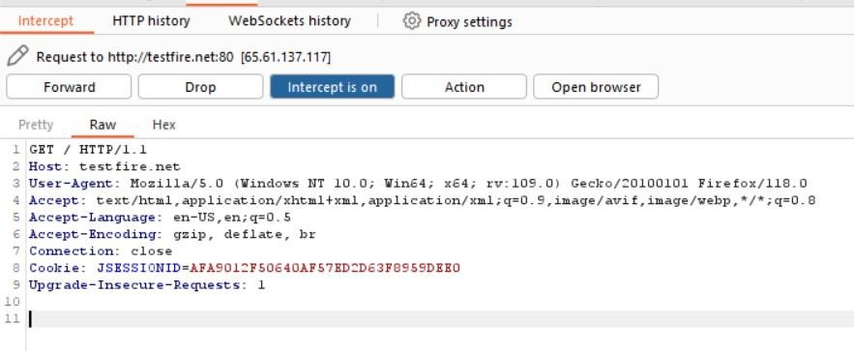

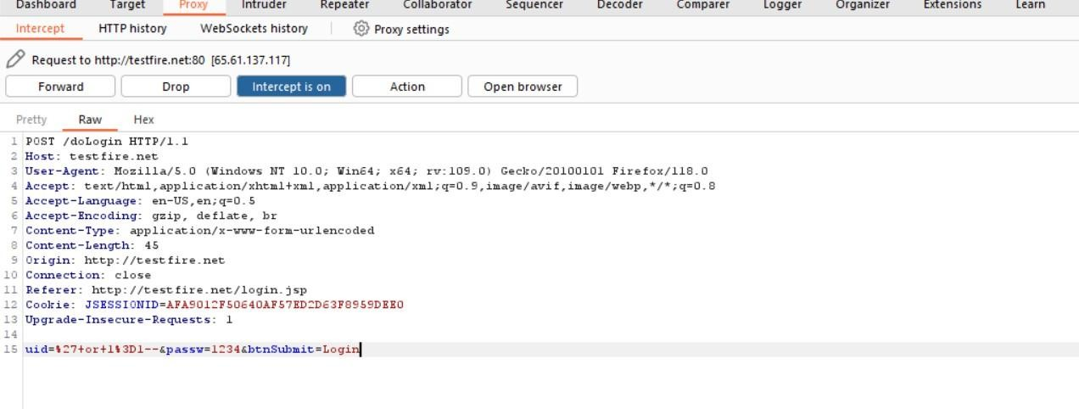

- Click forward request multiple times to proceed to the login page.

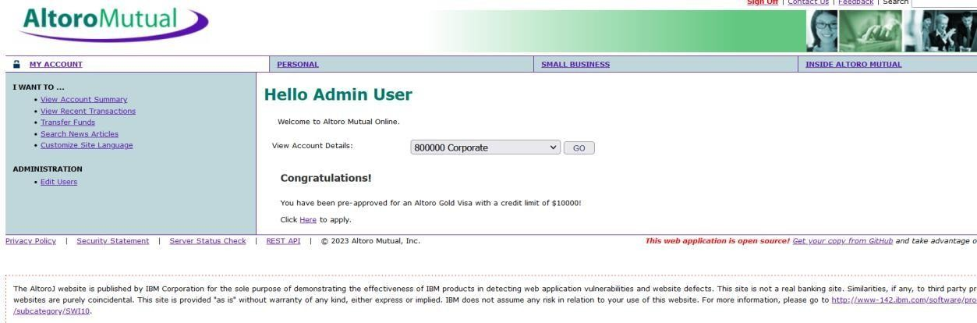
- With this we can know that sql injection worked and we got the admin privileges.

Recommendations
▪ Use trusted and verified third-party libraries from reliable repositories.
▪ Continuously monitor and update dependencies using dependency scanning tools.
▪ Implement code signing and integrity verification for software components.
▪ Maintain a software bill of materials (SBOM) to track all third-party components used in the application.

4. Vulnerability name: Cryptographic Failures
CWE: 320
OWASP Category: A04:2025 - Cryptographic Failures
Description: Key management errors occur when cryptographic keys used for encryption and decryption are not properly generated, stored, protected, or managed. Poor key management practices may include hardcoding keys in the application, using weak keys, or failing to rotate and securely store them. These mistakes can expose sensitive data and weaken the security of the entire system. Proper key management is essential to ensure that encryption mechanisms remain effective.
Business Impact: Key management errors can lead to unauthorized access to encrypted data and sensitive information. Attackers who obtain encryption keys may decrypt confidential data such as passwords, financial records, or personal information. This can result in serious data breaches and loss of customer trust. It may also lead to financial losses, legal penalties, and damage to the organization’s reputation
.Vulnerability path: http://testfire.net/
Vulnerability parameter: http://testfire.net/login.jsp
Steps to Reproduce:
- Access the URL


- Now we will try to login using some different approach.

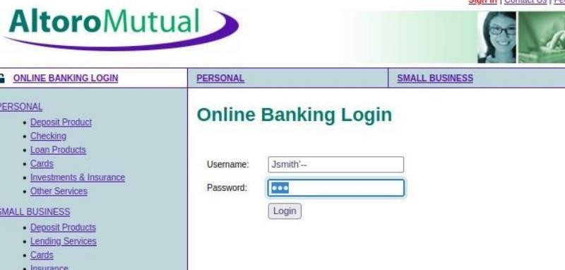
- As we know which users are present in the database of this website by using the admin privileges. We can directly access a particular user by simply knowing their username; we will add some characters after his user name as a sql injection to simply bypass the password.
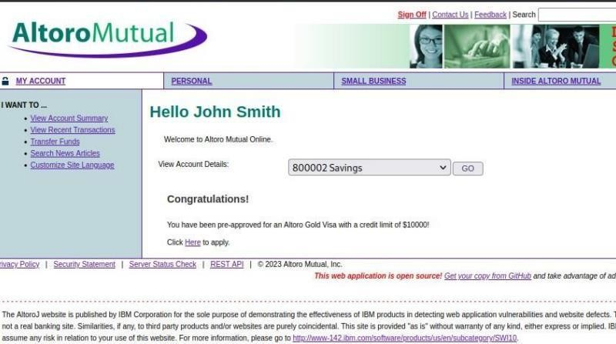
- This leads us to the details of this person’s account.
Recommendation
▪ Use strong encryption algorithms such as AES-256 and TLS 1.2 or TLS 1.3 for data protection.
▪ Avoid storing sensitive data such as passwords in plain text; use secure hashing algorithms like bcrypt or Argon2.
▪ Protect cryptographic keys using secure key management systems.
▪ Ensure proper encryption for both data at rest and data in transit.

5. Vulnerability name: Injection
CWE: 20
OWASP Category: A05:2025 - Injection
Description: Improper input validation occurs when a system does not properly check or filter the data entered by users before processing it. Applications should verify that all inputs meet expected formats, types, and lengths. If input validation is missing or weak, attackers may insert malicious data such as scripts or commands. This can lead to security vulnerabilities like injection attacks or system manipulation.
Business Impact: Improper input validation can allow attackers to exploit the system and gain unauthorized access to data or functions. It may lead to data breaches, system crashes, or unauthorized modification of information. Such vulnerabilities can disrupt business operations and compromise sensitive data. This may also cause financial losses and damage the organization’s reputation.
Vulnerability path: http://testfire.net/
Vulnerability parameter: http://testfire.net/login.jsp
Steps to Reproduce:

- Go to the domain. ➢ Sign into the site.
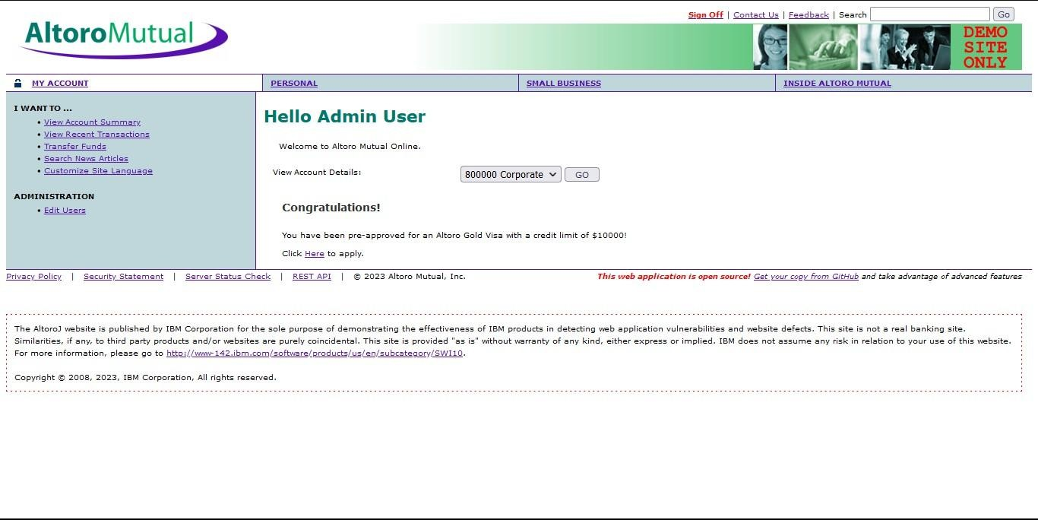
- Open “Transfer Money” on the left side and fill in the details. On the intercept and click transfer
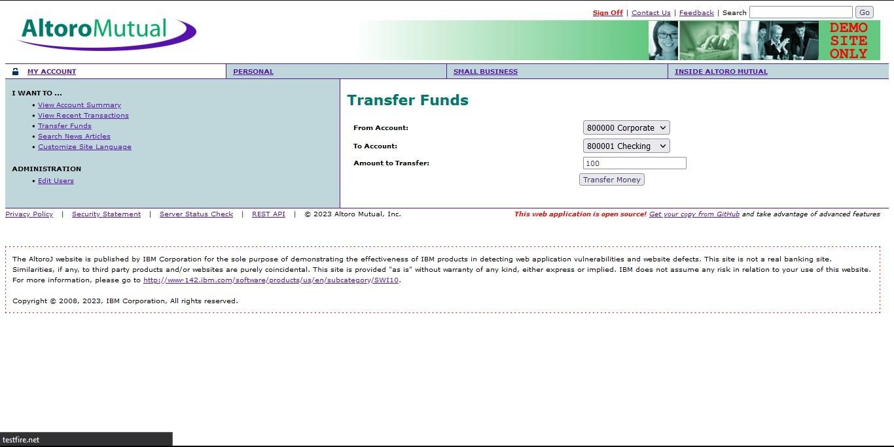
- Open burp and notice the change.

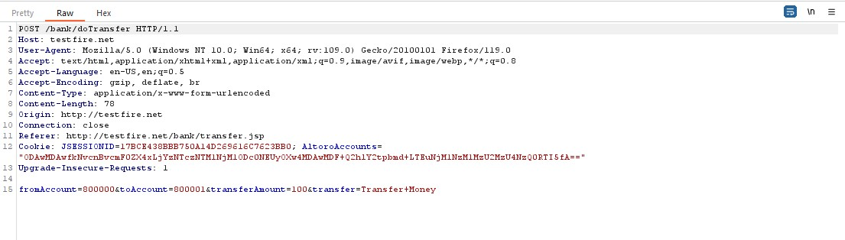
- In the 15th line change the amount from 100 to 1000 and click forward

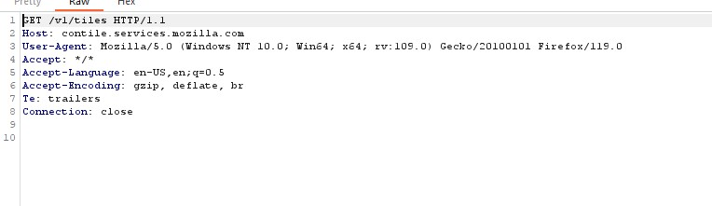
- Look at the site, we can notice the msg that shows the transfer of 1000.

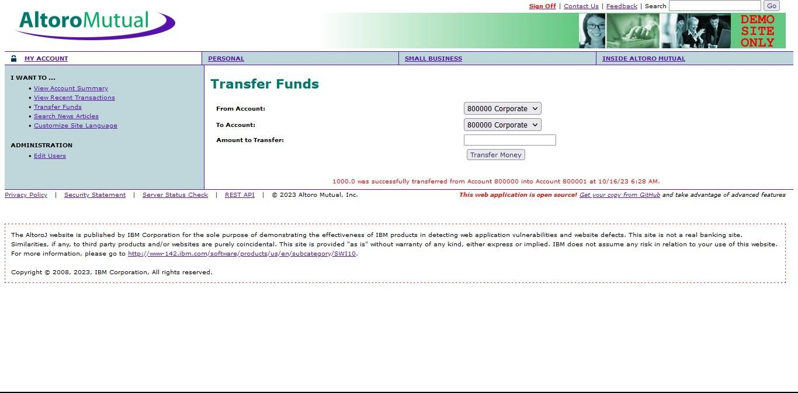

- Off the Intercept and open “View Recent Transactions”.

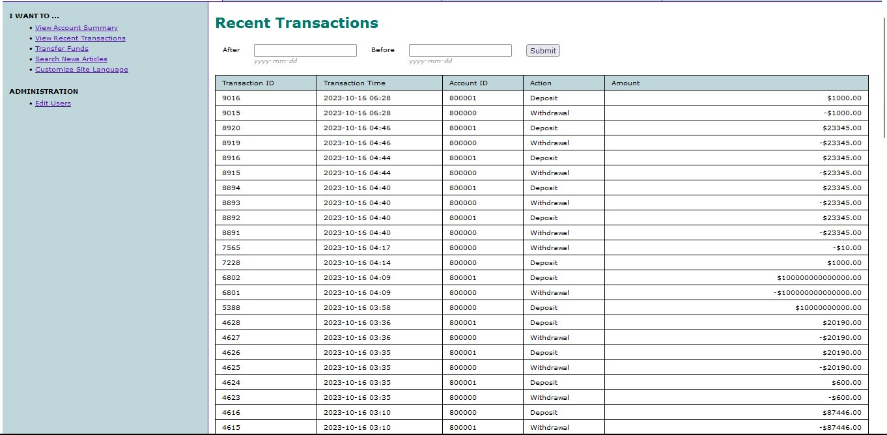

Recommendation
▪ Validate and sanitize all user inputs before processing them in the application.
▪ Use prepared statements or parameterized queries when interacting with databases.
▪ Implement input validation frameworks and secure coding practices.
▪ Perform regular security testing such as penetration testing and code reviews to detect injection vulnerabilities.
6. Vulnerability name: Insecure Design
CWE: 73
OWASP Category: A06:2025 - Insecure Design
Description: External control of file name or path occurs when a program allows users to specify file names or file paths without proper validation or restriction. If the application directly uses this input to access files, attackers may manipulate the path to access unauthorized files or directories. This vulnerability is often associated with path traversal attacks, where attackers attempt to access sensitive system files. Proper validation and restriction of file paths are necessary to prevent unauthorized file access.
Business Impact: This vulnerability can allow attackers to read, modify, or delete sensitive files within the system. They may access confidential data such as configuration files, passwords, or system information. This can lead to data breaches, system compromise, and disruption of business operations. As a result, the organization may face financial losses, legal issues, and damage to its reputation.
Vulnerability path: http://testfire.net/
Vulnerability parameter: http://testfire.net/login.jsp
Steps to Reproduce:

- Access the URL

- We will be using the uniscan tool which is available in the kali.

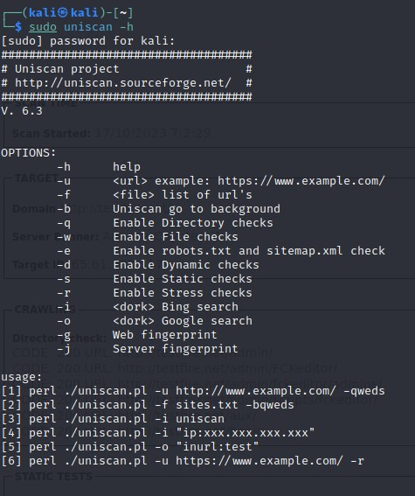
- We will use this tool to scan for hidden directories that can be access due to poor security measures taken in this website.

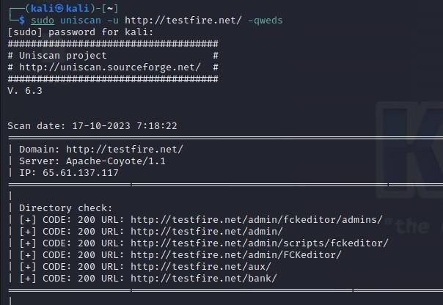

- We found directories that can be accessed easily. Also all the files that are present in the website has also been found.

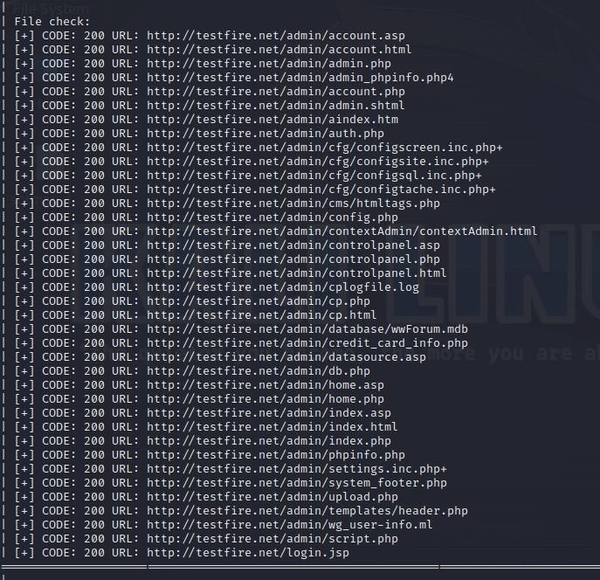

- Let us go through one webpage to see the vulnerability
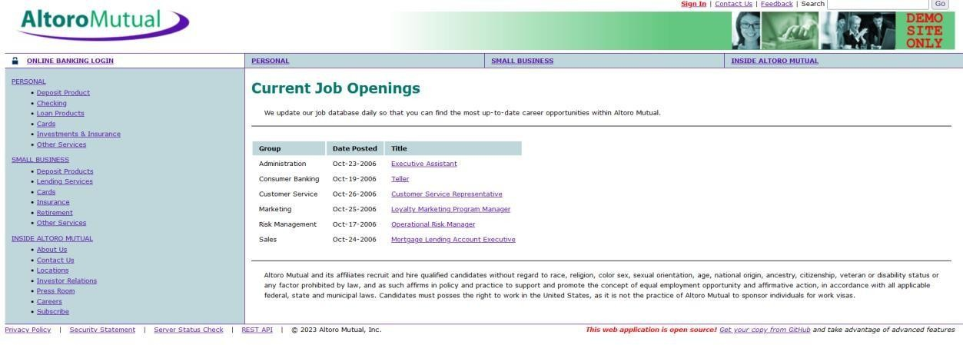

Recommendation
▪ Follow secure software development lifecycle (SSDLC) practices during application development.
▪ Conduct threat modeling and risk assessment during the design phase.
▪ Implement security controls and validation mechanisms early in the development process.
▪ Regularly review system architecture to identify potential design weaknesses.

7. Vulnerability name: Authentication Failures
CWE: 258
OWASP Category: A07:2025 - Authentication Failures
Description: An empty password in a configuration file occurs when a system or application stores a configuration setting with a blank or missing password. Configuration files often contain important credentials used to access databases, servers, or services. If the password field is left empty, the system may allow access without proper authentication. This creates a serious security weakness because unauthorized users may easily access sensitive resources.
Business Impact: This vulnerability can allow attackers or unauthorized users to gain access to critical systems or databases without any authentication. As a result, sensitive information may be exposed, modified, or deleted. It can lead to data breaches, system misuse, and operational disruptions. Such incidents may cause financial loss and damage the organization’s reputation.
Vulnerability path: http://testfire.net/
Vulnerability parameter: http://testfire.net/login.jsp
Steps to Reproduce:

- Open https://testfire.net/.
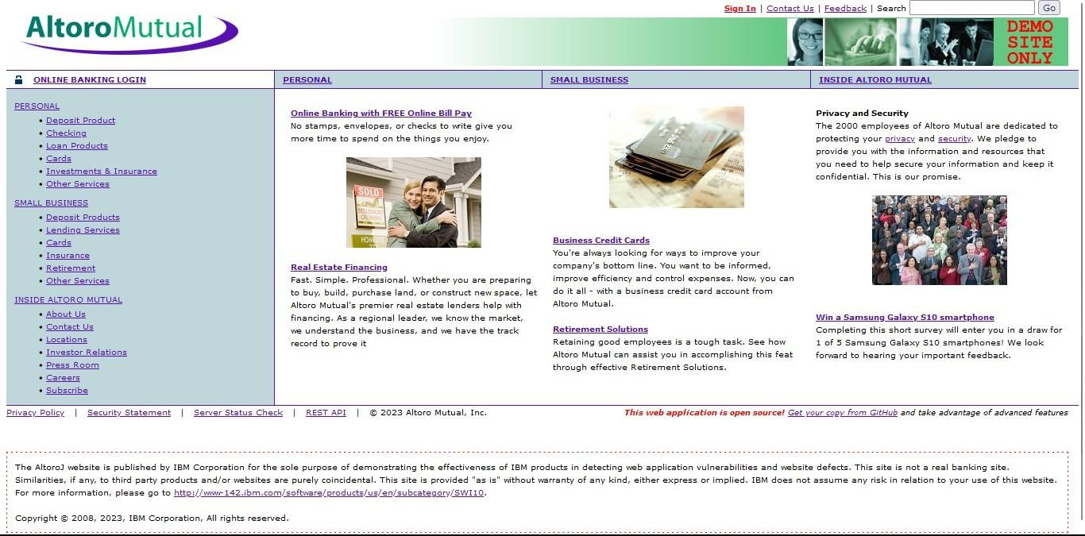

- Login to it using default credentials, and you will find two accounts.
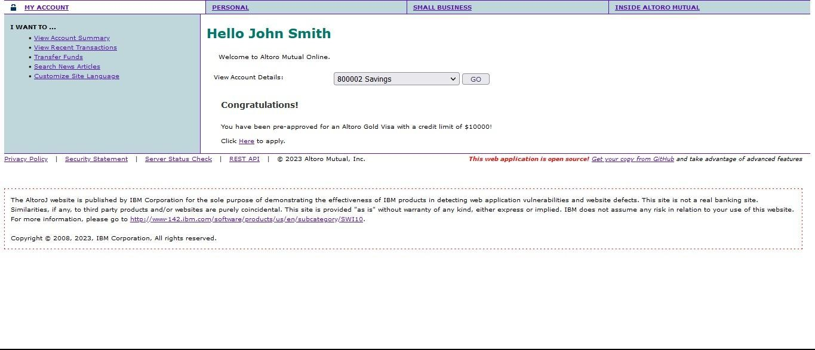

- Capture the request in any Intercepting proxy (Burp Suite, Charles Proxy etc.) while transferring the amount from one account to another as shown in the below picture.

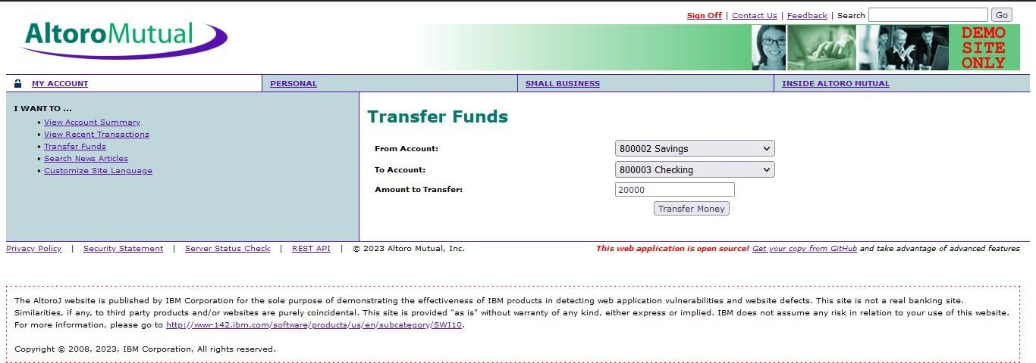
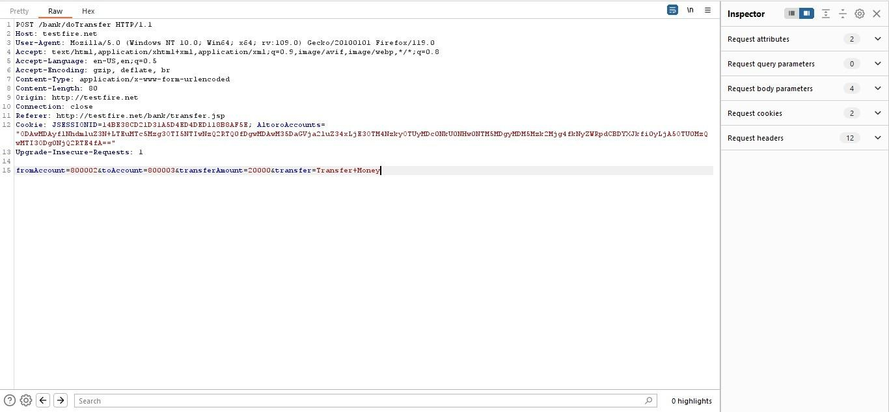

- Generate CSRF POC using Burp Suite Engagement tools (by modifying the account numbers accordingly)

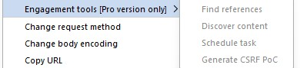
- As the victim is already logged-in to the site an attacker can send the crafted malicious form/URL to the user to his email/text/by any other means and trick the victim using his social engineering skills/techniques like below.

- User thinks, he could use a free $100 gift card! What could go wrong? You open the email and click the link/open the attachment.

- Once the user opens the form a transaction is automatically performed from his account without his knowledge as the user is already logged in.

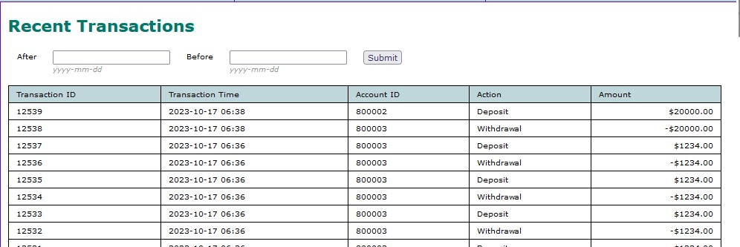

Recommendation
▪ Enforce strong password policies including complexity and length requirements.
▪ Implement multi-factor authentication (MFA) for sensitive systems.
▪ Limit login attempts and implement account lockout mechanisms to prevent brute-force attacks.
▪ Secure authentication tokens and use proper session management techniques.
8. Vulnerability name: Software or Data Integrity Failures
CWE: 345
OWASP Category: A08:2025 - Software or Data Integrity Failures
Description: Insufficient verification of data authenticity occurs when a system fails to properly confirm whether the received data is genuine and comes from a trusted source. Applications should verify data integrity and authenticity using mechanisms such as digital signatures, certificates, or secure communication protocols. If these checks are weak or missing, attackers may modify or inject fake data into the system. This can cause the system to process untrusted or malicious information.
Business Impact: This vulnerability can allow attackers to tamper with data or introduce false information into the system. As a result, the system may make incorrect decisions or perform unauthorized actions. It may lead to data corruption, security breaches, and loss of system reliability. These issues can cause operational problems, financial losses, and damage to the organization’s reputation.
Vulnerability path: http://testfire.net/
Vulnerability parameter: http://testfire.net/login.jsp
Steps to reproduce:
- Access the URL


- Now we will try to sign in to this website with admin privileges


- Also, we will be using burp suite to get requests from the website and know additional information.
- We use ‘admin’ for the username and password.

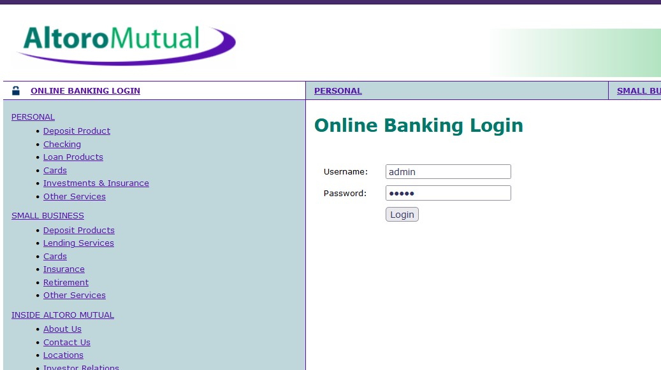
- This request has been received in the burp suite with the username and password as well in clear text.


Recommendation
▪ Use digital signatures and integrity checks to verify software updates and files.
▪ Implement secure CI/CD pipelines to prevent unauthorized code modifications.
▪ Monitor system files for unexpected changes using integrity monitoring tools.
▪ Restrict permissions to prevent unauthorized modification of application data.
9. Vulnerability name: Security Logging and Alerting Failures
CWE: 117
OWASP Category: A09:2025 - Security Logging and Alerting Failures
Description: Improper output neutralization for logs occurs when an application records user input or system data in log files without properly filtering or sanitizing it. If special characters or malicious input are not neutralized, attackers may inject harmful content into the logs. This can manipulate log entries, hide malicious activities, or corrupt the logging system. Proper validation and encoding of log data are necessary to maintain accurate and secure log records.
Business Impact: This vulnerability can allow attackers to alter or hide important log information, making it difficult for administrators to detect security incidents. It may also lead to incorrect monitoring and auditing of system activities. As a result, organizations may fail to identify attacks or system misuse in time. This can cause security breaches, operational issues, and potential financial or reputational damage.
Vulnerability path: http://testfire.net/
Vulnerability parameter: http://testfire.net/login.jsp
Steps to reproduce:
- Access the URL


- Then take the URL and use it for the html code
- we will be writing some html code to perform this vulnerability. we will be writing the code in vs code for better flexibility and functionality.

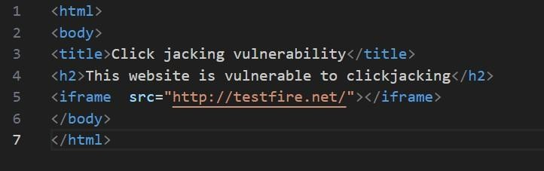

- After the code has been written then we will be executing the code in the browser.
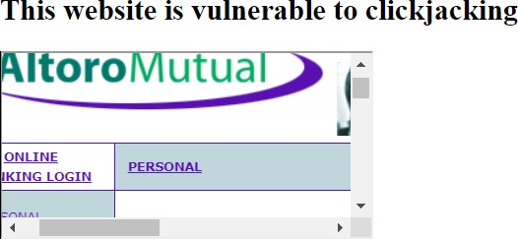

- From this image we can see that the vulnerability has been found.
Recommendation
▪ Enable detailed logging for authentication, access attempts, and system events.
▪ Store logs securely and protect them from unauthorized access or modification.
▪ Integrate logs with Security Information and Event Management (SIEM) systems for monitoring.
▪ Configure real-time alerts to notify administrators of suspicious activities.

10.. Vulnerability name: Mishandling of Exceptional Conditions
CWE: 209
OWASP Category: A10:2025 - Mishandling of Exceptional Conditions
Description: This vulnerability occurs when an application displays detailed error messages that reveal sensitive system information. These messages may include database queries, file paths, server details, or application configurations. Attackers can use this information to understand the system structure and identify possible weaknesses. Error messages shown to users should be limited and should not expose internal system details.
Business Impact: Exposing sensitive information through error messages can help attackers plan targeted attacks on the system. It may lead to unauthorized access, data breaches, or system exploitation. Such vulnerabilities can compromise confidential data and system security. This may result in financial loss and damage to the organization’s reputation.
Vulnerability path: http://testfire.net/
Vulnerability parameter: http://testfire.net/login.jsp
Steps to reproduce:
- Access the URL


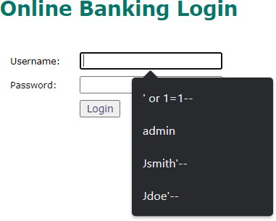

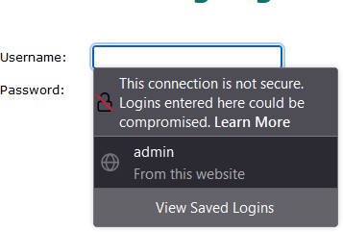

- From this image we can see the usernames and the passwords getting auto filled. This is a potential vulnerability as this can be a doorway for attacker

Recommendation
▪ Implement proper error handling mechanisms that do not expose sensitive system information.
▪ Log exceptions securely for debugging while avoiding exposure to users.
▪ Validate application responses during unexpected conditions to maintain system stability.
▪ Perform regular testing for edge cases and failure scenarios to ensure the system handles errors safely.

STAGE 2
Overview
Nessus is a powerful vulnerability assessment tool developed by Tenable that is used to identify security weaknesses in networks, operating systems, databases, and applications. It is widely used by security professionals, system administrators, and organizations to perform regular security assessments and detect potential vulnerabilities before attackers can exploit them. Nessus helps improve the overall security posture of an organization by providing automated vulnerability scanning and detailed security reports.
Nessus works by scanning systems and comparing their configurations with a continuously updated vulnerability database that contains information about known security issues, software bugs, misconfigurations, and missing patches. During the scanning process, Nessus examines open ports, running services, installed software versions, and system settings to detect potential vulnerabilities. It can identify issues such as outdated operating systems, weak encryption protocols, insecure network services, and misconfigured security settings.
The tool supports different types of scans, including network vulnerability scanning, web application scanning, configuration auditing, and compliance checks. These scans help organizations detect security flaws in servers, routers, firewalls, and other network devices. Nessus also provides credentialed scanning, which allows deeper inspection of systems by using authorized login credentials to check internal configurations and patch levels.
After completing a scan, Nessus generates a comprehensive report that lists all detected vulnerabilities along with their severity levels. The vulnerabilities are classified into categories such as Critical, High, Medium, Low, and Informational, allowing security teams to prioritize remediation efforts based on risk level. Each vulnerability entry includes a detailed description, possible impact, affected systems, and recommended solutions or patches.
Nessus also provides risk scores, vulnerability trends, and remediation guidance to help organizations manage security risks effectively. Security teams can use these reports to fix vulnerabilities, update software, improve system configurations, and strengthen overall security controls. Regular vulnerability scanning using Nessus is an important part of cybersecurity practices and helps organizations prevent cyberattacks, protect sensitive data, and maintain compliance with security standards and regulations.
Overall, Nessus plays a crucial role in vulnerability management by continuously monitoring systems, identifying security weaknesses, and helping organizations maintain a secure IT environment.

S. No | Vulnerability Name | Severity | Plugins
1. | Cross-site scripting (stored) | Low | Web application Scanner
2. | Broken Access Control | Medium | SSH weak HMAC Algorithms Supported
3. | SQL Injection | Medium | N/A
4. | Broken Authentication | Low | HSTS Missing from Server
5. | Insecure Direct Object Reference | Info | Service Detection
6. | Security Misconfiguration | Low | SSL cipher Block Chaining cipher suites
7. | Cross-Site Request Forgery | Low | HTTP Form- Based Authentication  Detected
8. | Cleartext Transmission of Sensitive Information | Medium | Cleartext Transmission of Sensitive Information over HTTP
9. | ClickJacking | Info | HTML Rendering Layer Vulnerability
10. | webserver allows password auto- completion | Low | SSL/TLS Diffie-Hellman Modulus<=1024 bits(Logjam)

Target Website: testfire.net

Target IP Address: 54.83.41.36

Report
1. Vulnerability Name: Cross-Site Scripting (Stored)
Severity: Low
Plugin: Web Application Scanner
Port: N/A
Description:
Stored Cross-Site Scripting (XSS) occurs when a malicious script is permanently stored within a web application, such as in a database, message board, or comment field. When the stored data is later retrieved and displayed to users without proper sanitization, the malicious script executes in the user’s browser. This allows attackers to inject harmful scripts that may affect users who view the compromised content.
Solution:
- Use parameterized queries or prepared statements when interacting with databases to reduce the risk of injection attacks.
- Validate and sanitize all user inputs before storing or displaying them.
- Apply proper output encoding techniques to prevent execution of malicious scripts.
Business Impact: This vulnerability allows attackers to store malicious content that is later displayed to other users. If privileged users access the affected page, the attacker may perform actions on their behalf or gain access to sensitive information. This could lead to unauthorized activities and compromise of confidential data.
2. Vulnerability Name: Broken Access Control
Severity: Medium
Plugin: SSH Weak HMAC Algorithms Supported
Port: N/A
Description:
Broken access control occurs when an application fails to properly enforce authorization rules. As a result, users may access restricted resources or perform actions beyond their intended permissions. This vulnerability can lead to data exposure, system misuse, or other security issues.
Solution:
- Implement strong authentication and authorization mechanisms.
- Ensure that users are properly authenticated before performing sensitive actions.
- Apply secure session management practices such as strong session IDs, session timeouts, and session token regeneration after login.
Business Impact: Broken access control can result in unauthorized access to critical systems and data. It may lead to data leaks, operational disruptions, legal liabilities, and financial losses, ultimately damaging the organization’s reputation and customer trust.
3. Vulnerability Name: SQL Injection
Severity: Medium
Plugin: N/A
Port: 80 / 443
Description:
SQL Injection occurs when user-controlled input is used to construct SQL queries without proper validation or sanitization. Attackers can manipulate input fields to inject malicious SQL commands, allowing them to access, modify, or delete database information.
Solution:
- Use parameterized queries or prepared statements to separate SQL code from user input.
- Implement strict input validation and escaping techniques.
- Use stored procedures where possible to limit direct interaction with database queries.
Business Impact: SQL Injection can lead to serious consequences such as database compromise, exposure of confidential information, financial losses, and operational disruption. Preventing SQL injection is critical for maintaining application security and protecting sensitive organizational data.
4. Vulnerability Name: Broken Authentication
Severity: Low
Plugin: HSTS Missing from HTTPS Server (Plugin ID: 142960)
Port: 443
Description:
Broken authentication occurs when authentication or session management mechanisms are implemented incorrectly. This may allow attackers to impersonate users or gain access to other users’ accounts by manipulating session identifiers or authentication parameters.
Solution:
- Implement strong authentication mechanisms such as Multi-Factor Authentication (MFA).
- Use secure password storage and encryption methods.
- Ensure proper session management with session timeouts and secure session tokens.
Business Impact: Weak authentication controls can lead to account compromise and unauthorized access to sensitive data. This may damage user trust and negatively affect the organization's overall security posture.
5. Vulnerability Name: Insecure Direct Object Reference (IDOR)
Severity: Informational
Plugin: Service Detection (Plugin ID: 22964)
Port: 80 / 443
Description:
IDOR occurs when a web application exposes internal object references such as file names, database IDs, or record identifiers without verifying user authorization. Attackers may manipulate these references to access unauthorized resources.
Solution:
- Implement strong access control mechanisms to verify user permissions.
- Avoid exposing direct object identifiers in URLs.
- Use indirect references or mapping mechanisms to protect sensitive objects.
Business Impact: This vulnerability can allow attackers to access or modify sensitive information without authorization. Strengthening access control measures helps protect confidential data and maintain system integrity.

6. Vulnerability Name: Security Misconfiguration
Severity: Low
Plugin: SSL Cipher Block Chaining Cipher Suites
Port: 443
Description:
Security misconfiguration occurs when systems, applications, or servers are not securely configured. Improper permissions or insecure settings may allow unauthorized users to access or modify critical resources.
Solution:
- Follow vendor-recommended security configuration guidelines.
- Implement change management processes for configuration updates.
- Conduct regular security audits and compliance checks.
Business Impact: Misconfigured systems can expose sensitive data and weaken system defenses. Proper configuration management helps protect systems from unauthorized access and security breaches.
7. Vulnerability Name: Cross-Site Request Forgery (CSRF)
Severity: Low
Plugin: HTTP Form-Based Authentication Detected
Port: 8080 / 443
Description:
CSRF is an attack where a malicious website forces an authenticated user to perform unwanted actions on another web application. If the victim is logged in, the attacker can exploit the user’s session to execute actions such as data modification or transactions.
Solution:
- Implement anti-CSRF tokens to verify legitimate requests.
- Use the Same Site cookie attribute to restrict cross-site requests.
- Utilize framework security features designed to prevent CSRF attacks.
Business Impact: CSRF attacks can lead to unauthorized transactions, account changes, and system manipulation. Implementing secure coding practices helps prevent such attacks and protects user data.
8. Vulnerability Name: Cleartext Transmission of Sensitive Information
Severity: Medium
Plugin: Cleartext Transmission of Sensitive Information over HTTP
Port: 443
Description:
This vulnerability occurs when sensitive data is transmitted without encryption. Attackers monitoring network traffic may intercept and read confidential information such as passwords, session tokens, or personal data.
Solution:
- Use secure protocols such as HTTPS and TLS for data transmission.
- Implement encryption mechanisms for sensitive data in transit.
- Educate users about secure communication practices.
Business Impact: Unencrypted data transmission can result in data theft and privacy violations. Organizations may suffer financial losses, compliance issues, and loss of customer trust.
9. Vulnerability Name: Clickjacking
Severity: Informational
Plugin: HTML Rendering Layer Vulnerability
Port: 80 / 443
Description:
Clickjacking occurs when attackers trick users into clicking hidden or disguised elements within a web page. This is achieved by embedding the target application within an invisible frame or overlay.
Solution:
- Configure the X-Frame-Options header to prevent unauthorized framing.
- Implement Content Security Policy (CSP) to restrict iframe usage.
- Use frame-busting scripts to prevent malicious embedding.
Business Impact: Click jacking attacks may trick users into performing unintended actions such as approving transactions or changing settings. Preventing such attacks helps maintain user trust and application security.
10. Vulnerability Name: Web Server Allows Password Auto-Completion
Severity: Low
Plugin: SSL/TLS Diffie-Hellman Modulus ≤ 1024 Bits (Logjam)
Port: 443
Description:
This issue relates to weaknesses in cryptographic practices and password handling. Poor encryption techniques or weak key management can reduce data confidentiality and integrity.
Solution:
- Use strong hashing algorithms for password storage.
- Implement proper encryption key management and rotation.
- Use secure cryptographic libraries and updated encryption protocols.
Business Impact: Weak cryptographic practices can expose sensitive data and compromise system security. Implementing strong encryption and secure password storage is essential to protect user information and maintain organizational trust.

S. NO | VULNERABILITY NAME | SEVERITY | PLUGINS
1. | Cross-site scripting (DOM based XSS) | Medium | Multiple XSS
2. | jQuery 1.3<3.5.0 Multiple XSS | Medium | CGI Abuse: XSS
3. | Information exposure (web server HTTP header internal IP disclosure) | Low | Webserver HTTP  Header Internal IP Disclosure
4. | Information exposure (SSL (Multiple Issues)) | Info | SSL Certificate Information
5. | Information exposure (HTTP (Multiple Issues)) | Info | HTTP Information
6. | OS identification failed | Info | TCP/IP Remote Probing

TARGET WEBSITE: vit.ac.in

TARGET IP ADDRESS: 122.184.65.22

Report

1. Vulnerability Name: Cross-Site Scripting (DOM-Based XSS)
Severity: Medium
Plugin: Multiple XSS
Port: 443
Description: DOM-based Cross-Site Scripting (XSS) occurs when malicious scripts are injected into a web application and executed in the user’s browser through manipulation of the Document Object Model (DOM). The DOM is a programming interface for HTML and XML documents that allows scripts to dynamically modify the structure, style, and content of a webpage. When a web application processes user input without proper validation or encoding, attackers can manipulate the DOM to execute harmful scripts within the browser.
Solution:
- Use parameterized or prepared statements when interacting with databases to minimize injection vulnerabilities.
- Sanitize and validate all user inputs before processing or displaying them.
- Avoid unsafe DOM manipulation methods such as inner HTML and document.write that may allow script execution.
- Use trusted JavaScript frameworks and libraries that provide built-in security mechanisms against DOM-based XSS.
Business Impact: Attackers may inject malicious scripts into web pages viewed by multiple users. If privileged users access the compromised content, the attacker could perform actions on their behalf or access sensitive information. This could lead to unauthorized operations, data theft, and potential compromise of application security.

2. Vulnerability Name: jQuery 1.2 < 3.5.0 Multiple XSS
Severity: Medium
Plugin: CGI Abuse: XSS
Port: 443
Description: This vulnerability occurs due to outdated versions of the jQuery library that contain multiple Cross-Site Scripting (XSS) weaknesses. These vulnerabilities allow attackers to inject malicious scripts that may be stored on the server, reflected through URLs, or executed through DOM manipulation. When users interact with affected pages, the injected scripts may execute in their browsers and compromise their sessions or data.
Solution:
- Update the jQuery library to the latest secure version.
- Monitor security advisories and updates related to the library.
- Implement a Content Security Policy (CSP) to restrict the sources from which scripts can be loaded.
- Review existing code to ensure proper input validation and secure coding practices.
Business Impact: If exploited, attackers can inject malicious code that executes in users’ browsers. This could lead to session hijacking, data theft, or unauthorized actions performed on behalf of legitimate users. Such incidents may damage user trust and compromise application security.

3. Vulnerability Name: Information Exposure (Web Server HTTP Header Internal IP Disclosure)
Severity: Low
Plugin: Web Server HTTP Header Internal IP Disclosure
Port: 80
Description: This vulnerability occurs when a web server unintentionally exposes internal IP addresses through HTTP response headers. Attackers can use this information to gain insights into the internal network structure, which may assist in further attacks.
Solution:
- Review server configuration files such as httpd.conf or nginx.conf to identify any internal IP information exposed in headers.
- Replace internal IP addresses with public addresses or remove them from responses.
- Configure proxies or load balancers to hide internal network details.
- Limit information disclosed in HTTP headers such as Server and X-Powered-By.
Business Impact: Exposure of internal IP addresses may provide attackers with valuable information about the system infrastructure. This can increase the risk of targeted attacks and may compromise the organization’s network security.

4. Vulnerability Name: Information Exposure (SSL Multiple Issues)
Severity: Informational
Plugin: SSL Certificate Information
Port: 443
Description: This issue occurs when SSL/TLS configurations reveal sensitive certificate or encryption details to unauthorized parties. Weak encryption protocols or improper certificate management may expose information that could assist attackers in compromising secure communications.
Solution:
- Configure the server to use modern encryption protocols such as TLS 1.2 or higher.
- Disable outdated protocols such as SSLv3.
- Implement Perfect Forward Secrecy (PFS) to enhance encryption security.
- Securely store and manage private keys to prevent unauthorized access.
Business Impact: Weak SSL/TLS configurations may compromise the security of encrypted communications. Attackers may exploit such weaknesses to intercept or manipulate sensitive information, which could harm user trust and the organization’s reputation.

5. Vulnerability Name: Information Exposure (HTTP Multiple Issues)
Severity: Informational
Plugin: HTTP Information
Port: 80 / 443
Description: This vulnerability occurs when HTTP responses reveal unnecessary information about the server, application, or configuration. Such information may assist attackers in identifying potential vulnerabilities in the system.
Solution:
- Reduce unnecessary redirects to improve performance and security.
- Monitor and fix broken links or HTTP errors such as 404 responses.
- Properly configure Cross-Origin Resource Sharing (CORS) policies.
- Ensure secure communication by migrating fully to HTTPS.
Business Impact: Exposure of unnecessary information through HTTP responses may provide attackers with insights into the application structure. Continuous monitoring and maintenance are required to ensure a secure and reliable web service environment.

6. Vulnerability Name: OS Identification Failed
Severity: Informational
Plugin: TCP/IP Remote Probing
Port: N/A
Description: OS Identification Failed indicates that the scanning tool was unable to determine the operating system running on the target system. This may occur due to network restrictions, firewall configurations, or incomplete responses during scanning. Accurate OS identification is important for identifying potential vulnerabilities and applying appropriate security measures.
Solution:
- Verify network configurations and ensure scanning permissions are correctly set.
- Ensure systems respond properly to scanning requests where necessary.
- Maintain updated system configurations and documentation to support accurate vulnerability assessments.
Business Impact: Failure to identify the operating system may limit the effectiveness of vulnerability assessments and security monitoring. This can lead to incomplete security evaluations, increased operational risks, and potential compliance issues if vulnerabilities remain undetected.

Stage – 3

Title:
Enforce least-privilege access through identity-aware, application-specific access policies using Zscaler Private Access (ZPA).

Zero Trust Network Access (ZTNA)
Zero Trust Network Access (ZTNA) is a modern cybersecurity approach that changes the traditional network-based security model to an identity-based access model. The main concept of ZTNA is “never trust, always verify.” This means that no user or device is automatically trusted, even if they are inside the organization’s network. Every access request must be verified before permission is granted.
Unlike traditional remote access technologies such as VPNs, which often provide users with broad access to the internal network, ZTNA allows access only to specific applications that a user is authorized to use. It creates a secure, application-level connection between the user and the requested resource. This prevents unauthorized users from discovering internal systems and significantly reduces the overall attack surface. As a result, attackers cannot easily move laterally across the network.
Zscaler Private Access (ZPA)
Zscaler Private Access is a cloud-based Zero Trust Network Access solution that enables secure access to private applications without providing network-level connectivity. Instead of connecting users directly to the corporate network, ZPA connects them through the Zscaler cloud platform, which acts as a broker between the user and the application.
ZPA follows a service-initiated architecture. In this model, users connect to the Zscaler cloud, which then establishes a secure connection to the required application through ZPA App Connectors deployed in the organization’s data center or cloud environment. Because the user is never directly connected to the internal network, internal IP addresses and infrastructure remain hidden.
Access policies are dynamically enforced based on several factors such as user identity, group membership, device security status, and location. This ensures that users can only view and access the applications they are specifically authorized to use.
Principle of Least Privilege (PoLP)
The Principle of Least Privilege (PoLP) is an important security concept that ensures users, devices, or processes are given only the minimum level of access required to perform their tasks. Instead of providing full network access, systems grant limited and application-specific permissions.
When implemented through ZPA, the least privilege principle prevents attackers from accessing other systems even if a user’s credentials are compromised. Since the network remains hidden and inaccessible, attackers cannot move laterally across systems. This approach helps reduce insider threats and limits the potential damage during a security incident.
Identity-Aware Access
Identity-aware access focuses on granting permissions based on who the user is, rather than where they are connecting from. ZPA integrates with identity providers such as Microsoft Azure Active Directory, Okta, and Ping Identity to authenticate users and apply access policies.
Using this integration, administrators can create detailed policies based on user attributes such as department, role, or group membership. For example, a policy may allow only users from the Finance department using approved company devices to access a specific financial application during working hours. This approach ensures that access decisions are based on user identity and contextual factors instead of traditional network-based controls.
Application-Specific Access Policies
Application-specific policies are the main enforcement mechanism within ZPA. Instead of granting access to entire networks or IP ranges, administrators create policies that allow access to individual applications or specific application groups.
These policies can include conditions such as user identity, device security status, geographic location, and time of access. ZPA also supports micro-segmentation, where internal applications such as HR systems, development servers, internal portals, and databases are separated into different segments. This ensures that users can only access the applications required for their role and cannot view or connect to other internal systems.
ZPA Architecture and Components
The ZPA system consists of several components that work together to provide secure access.
1. Zscaler Cloud (Service Edge)
The Zscaler cloud platform acts as the central broker that connects users to applications. It handles authentication, policy evaluation, and connection management while maintaining high availability through a globally distributed infrastructure.
2. App Connectors
App Connectors are lightweight virtual machines or containers deployed in private data centers or cloud environments. They establish outbound secure connections to the Zscaler cloud and forward user traffic to internal applications. Because they initiate outbound connections, no inbound firewall rules are required.
3. ZPA Client Connector
The Client Connector is software installed on user devices such as Windows, macOS, Linux, iOS, and Android systems. It authenticates users, verifies device security compliance, and creates secure micro-tunnels to the Zscaler cloud for application access.
4. Application Segments
Application segments are logical groups of internal applications defined in the ZPA administrative console. These segments represent the private resources that users are permitted to access based on defined policies.
Implementation Methodology
The deployment of ZPA is typically performed in several phases to ensure smooth migration and minimal disruption.
Phase 1 – Discovery and Inventory:
All internal applications are identified and categorized based on department usage, business importance, and user groups.
Phase 2 – Connector Deployment:
ZPA App Connectors are installed in data centers or cloud platforms using virtualization technologies such as VMware, Hyper-V, or cloud images.
Phase 3 – Application Onboarding:
Applications are defined in the ZPA console with their IP addresses and ports, and they are assigned to App Connector groups.
Phase 4 – Policy Creation:
ZPA is integrated with the organization’s identity provider. Access policies are then created based on user roles, devices, and locations.
Phase 5 – Pilot Deployment:
A small group of users tests the new system, providing feedback and helping refine policies before full deployment.
Phase 6 – VPN Replacement:
After successful migration, legacy VPN systems are gradually removed to eliminate traditional network-based access risks.
Tools and Technologies
Several tools and technologies support the ZPA deployment.
- Primary Platform: Zscaler Private Access for Zero Trust connectivity
- Identity Providers: Microsoft Azure Active Directory, Okta, Ping Identity
- Endpoint Protection: CrowdStrike, SentinelOne, Microsoft Defender
- SIEM Platforms: IBM QRadar, Splunk, LogRhythm for security monitoring
- Virtualization Platforms: VMware vSphere, Microsoft Hyper-V, AWS, Azure, GCP
- Automation Tools: Terraform or Ansible for automated deployment
- Monitoring Tools: Digital Experience Monitoring solutions for user experience analysis
Integration with Identity Providers
Integration with identity providers is a crucial part of implementing identity-aware access. This integration usually uses authentication protocols such as SAML or LDAP.
When users attempt to access an application through the ZPA Client Connector, they are redirected to the organization’s identity provider for authentication and multi-factor authentication (MFA). Once authentication is successful, the identity provider sends user attributes and group information to ZPA, which then evaluates the defined access policies.
Device Posture Verification
ZPA can also evaluate the security condition of the user’s device before granting access. By integrating with endpoint detection and mobile device management tools, ZPA can verify several security parameters:
- Antivirus status and updates
- Disk encryption status
- Operating system patch level
- Detection of jailbroken or rooted devices
- Real-time risk score from endpoint protection tools
If the device does not meet the required security standards, ZPA may block access, provide limited access, or initiate remediation actions.
Micro-Tunneling and Application Visibility
ZPA establishes encrypted TLS or DTLS micro-tunnels between the user’s device and the Zscaler cloud, and another tunnel between the cloud and the App Connector. This creates a direct connection between the user and the application without exposing the corporate network.
Users can only resolve and connect to the specific applications they are authorized to access. All other internal systems remain completely invisible, preventing reconnaissance attacks and unauthorized network scanning.
Threat Intelligence Integration
ZPA can integrate with threat intelligence platforms and SIEM systems to enhance security monitoring. Logs related to user activity, connection attempts, and policy violations can be forwarded to security monitoring systems.
These logs can be analyzed alongside threat intelligence feeds to detect suspicious behavior. For example, if a login attempt originates from a known malicious IP address, the system can generate alerts and automatically block access.
Incident Response in a ZPA Environment
ZPA also supports efficient incident response procedures.
Isolation: Security teams can immediately revoke access for compromised users or devices.
Forensics: Detailed logs allow investigators to analyze which applications were accessed, from which location, and for how long.
Containment: Because users do not have network-level access, attackers cannot spread across the internal network.
Granular Blocking: Access to specific applications can be temporarily restricted while allowing normal business operations to continue.
Key Takeaways of ZPA
Zscaler Private Access introduces a modern approach to secure remote access.
- It is cloud-native, eliminating the need for traditional VPN hardware.
- It is identity-driven, focusing on users rather than IP addresses.
- It ensures network invisibility, protecting internal infrastructure from external exposure.
- It is highly scalable, supporting large numbers of users.
- It supports hybrid environments, including on-premises and cloud applications.
- It improves user experience by providing direct and optimized application access.

Conclusion

Stage 1
In conclusion, web application testing plays a vital role in ensuring the security, functionality, and reliability of web-based systems. It involves a detailed evaluation of different components such as the user interface, application functionality, performance, and security mechanisms to detect and resolve issues before they affect end users. Conducting thorough testing improves the overall quality of web applications and strengthens their ability to withstand potential cyber threats and vulnerabilities. In today’s digital era, where online platforms and services are widely used in everyday activities, effective web application testing is essential for providing a secure, efficient, and seamless user experience.

Stage 2
The Nessus vulnerability assessment report generated for the target website provides valuable insights into its current security status. The scan identified several vulnerabilities that were classified according to their severity levels, with particular attention given to critical and high-risk issues that require immediate remediation. The report also suggests corrective actions such as applying security patches, modifying system configurations, and implementing additional protective measures to mitigate the detected vulnerabilities. In addition, the recommendations align with recognized security standards and best practices, including the guidelines provided by the OWASP. The findings highlight the importance of continuous monitoring, timely updates, and regular security assessments to maintain a strong defensive posture. Overall, the Nessus report provides a comprehensive overview of the website’s security condition and emphasizes the need for ongoing vigilance to address emerging cyber threats.

Stage 3
The implementation of Zscaler Private Access represents a significant transition from a traditional network-based security approach to a modern identity-driven Zero Trust architecture. By enforcing the principle of least privilege and making private applications invisible to external networks, this solution effectively minimizes the risk of lateral movement and network-based attacks. The deployment not only strengthens the organization’s overall security framework but also ensures a smooth and high-performance access experience for remote and distributed users. Additionally, separating application access from the internal network simplifies IT management, reduces reliance on legacy VPN systems, and provides detailed visibility into user and application interactions. Ultimately, this implementation creates a robust and future-ready security foundation, enabling organizations to safely support their digital transformation initiatives.
Future Scope
Stage 1: Future Scope of Web Application Testing
The future of web application testing is highly promising and continues to evolve as internet usage and digital services expand rapidly. As organizations increasingly rely on web-based platforms, the need for effective and advanced testing methods will grow significantly.
Some important areas that define the future scope of web application testing include:
▪ Growing Demand: As businesses, government services, and educational platforms continue to move online, the demand for reliable web applications will increase. This growth will also raise the need for comprehensive testing to ensure applications remain secure, stable, and fully functional.
▪ Integration of Advanced Technologies: Modern web applications are incorporating advanced technologies such as Artificial Intelligence (AI), Internet of Things (IoT), and blockchain. Testing these sophisticated systems will require specialized tools and advanced testing strategies.
▪ Stronger Focus on Security: With the rising number of cyberattacks and data breaches, security testing will become even more important. Testers will need to concentrate on identifying vulnerabilities, protecting sensitive data, and ensuring compliance with international regulations such as General Data Protection Regulation.
▪ Mobile and Cross-Browser Compatibility: As mobile device usage continues to increase, web applications must function efficiently across multiple devices, screen sizes, and browsers. Testing for cross-browser and cross-platform compatibility will therefore remain essential.
▪ Improved Performance Testing: User expectations for faster and smoother applications are constantly increasing. Future testing processes will focus heavily on load testing, stress testing, and performance optimization to ensure applications can handle heavy traffic and high user demand.
Stage 2: Future Scope of the Web Application Testing Process
The future of the web application testing process, particularly in vulnerability identification and security assessment, is extremely promising due to the rapid expansion of digital platforms and the growing importance of cybersecurity. As cyber threats continue to evolve, testing methodologies will also advance to provide stronger protection.
Some key developments expected in the future include:
▪ AI-Driven Testing: The integration of Artificial Intelligence and Machine Learning into testing tools will transform vulnerability detection. AI systems will be capable of analyzing large volumes of code and application data quickly, allowing them to identify security weaknesses that may be difficult for human testers to detect.
▪ IoT and Mobile Application Testing: With the increasing use of IoT devices and mobile applications, web application testing will expand to include these environments. Ensuring the security of connected devices and their communication interfaces will become an important responsibility for security testers.
▪ Blockchain and Cryptocurrency Security: As blockchain technology and digital currencies gain wider adoption, security testing will play a key role in protecting financial transactions and digital assets. Testing blockchain-based systems will emerge as a specialized area in application security.
▪ Serverless Architecture Testing: The adoption of serverless computing platforms is increasing rapidly. Testing processes will need to adapt to evaluate the security of serverless functions and APIs to ensure they are protected from vulnerabilities.
▪ Container Security Testing: With containerization technologies such as Docker and Kubernetes becoming widely used in modern application deployment, testing practices will expand to include container security. This includes verifying container images, configurations, and orchestration systems to ensure they are free from vulnerabilities.
Stage 3: Future Scope of Zero Trust Architecture
The successful deployment of Zscaler Private Access creates a strong foundation for building a more advanced and integrated cybersecurity ecosystem. In the future, several improvements can be implemented to further enhance the organization’s security infrastructure.
▪ Integration with Zscaler Internet Access: Combining ZPA with Zscaler Internet Access will help organizations create a unified Secure Access Service Edge (SASE) environment, allowing both internet and private application traffic to be managed through a single security policy framework.
▪ Advanced Device Posture Verification: Future implementations may include more advanced device security checks, such as integrating real-time risk scores from Endpoint Detection and Response (EDR) tools to automatically block compromised devices.
▪ Privileged Remote Access: ZPA can be extended to support secure access for external vendors and contractors by providing time-limited and monitored access to specific critical systems, eliminating the need for traditional jump servers.
▪ IoT and OT Segmentation: Zero Trust principles can also be applied to Internet of Things (IoT) and Operational Technology (OT) environments, allowing these devices to communicate only with authorized management systems.
▪ AI-Based Anomaly Detection: Machine learning algorithms can analyze ZPA activity logs to identify unusual behavior patterns, such as access attempts from unusual locations or at abnormal times. These anomalies can trigger additional authentication steps or automatic access restrictions.
▪ Cloud Workload Protection: ZPA can be used to secure communication between containers, microservices, and workloads deployed across cloud platforms such as Amazon Web Services, Microsoft Azure, and Google Cloud Platform, ensuring encrypted and authenticated connections.
▪ Automated Access Management: By integrating identity providers with automated workflows, application access can be instantly granted or revoked when employees join, leave, or change roles within the organization.
▪ Digital Experience Monitoring: Implementing Digital Experience Monitoring tools will allow organizations to continuously monitor user experience and identify network or application performance issues before they affect productivity.
Topics Explored:
- Zscaler
- Zero trust
- ZPA
- VPN
- MISP
- College Network Information
- Deployment of SOC in the College
- Threat Intelligence
- Incident Response

Tools Explored:
- Nessus Scanner

